**Example B – Post Audit Management Letter**

**Date, 2017**

**Chief/President/Council**

**Address**

**XXX XXX**

**XXX XXX**

**Dear Chief/President/Council**

**Re: Audit of 2017 Consolidated Financial Statements**

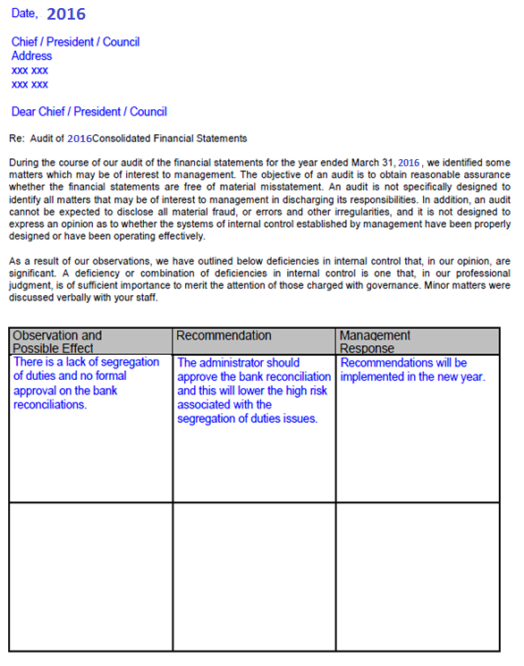

**During the course of our audit of the financial statements for the year ended March 31, 2016 we identified some matters which may be of interest to management. The objective of an audit is to obtain reasonable assurance whether the financial statements are free of material misstatement. An audit is not specifically designed to identify all matters that may be of interest to management in discharging tis responsibilities. In addition, an audit cannot be expected to disclose all material fraud, or errors and other irregularities, and it is not designed to express an opinion as to whether the systems of internal control established by management have been properly designed or have been operating effectively.**

**As a result of our observations, we have outlined below deficiencies in internal control that, in our opinion, are significant. A deficiency or combination of deficiencies in internal control is on that, in our professional judgment, is of sufficient importance to merit the attention of those charged with governance. Minor matters were discussed verbally with you staff.**

